- Write a program to enter a number of any length, and find whether its palindrome or not.
e.g., 12321 is palindrome. 12344321 is palindrome
- Write a program to print empty diamond
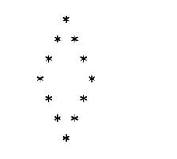
- Print the following for n lines
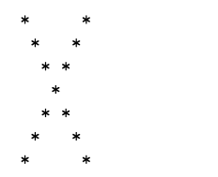

- Print of pattern of 0’s surrounded by stars
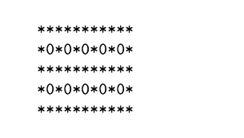
- Print pyramid of alphabets
A
A B A
A B C B A
A B C D C B A
A B C D E D C B A

- Write a program to enter a number and show how many times a digit appeared in number
e.g., n = 23531
1 =1 times
2 = 1 times
3= 2 times
5 = 1 times

- Print following sequence for n row

1 10 100 1000
2 20 200 2000
.
.
9 90 900 9000
- Write a program to enter a number and show how many times a digit appeared in number
e.g., n = 23531
1 =1 times
2 = 1 times
3= 2 times
5 = 1 times
- Write a program to enter an expression and display its result when = is pressed/
- Wrtie a program to print pascal’s triangle using formula
n! / k! (n – k )!
Where n is row number and k is column number, both starting at 0

